**MiniMiner Frame Instructions**

Supplies needed:

Drill Bits: 1/16”, 7/64”, 9/64”, 3/16”, 1/4”

10 – feet 1 x 1/8 inch Aluminum Flat Bar

20 - #6 x 1/2” Pan Phillips Screws

4 – M4x18mm Stand Offs with nuts and bolts

2 – IRWIN VISE-GRIP Original Locking Sheet Metal Tool, 8”, 23

1 - Bag 8” Nylon Ties

1 – Bag 3” Nylon Ties

1. Print two copies of MinerFrame1 and one copy of MinerFrame2 pdf. Make sure to select Actual Size in your print settings.
2. Verify MinerFrame1 and MinerFrame2 are exactly 10 inches on the reference line.

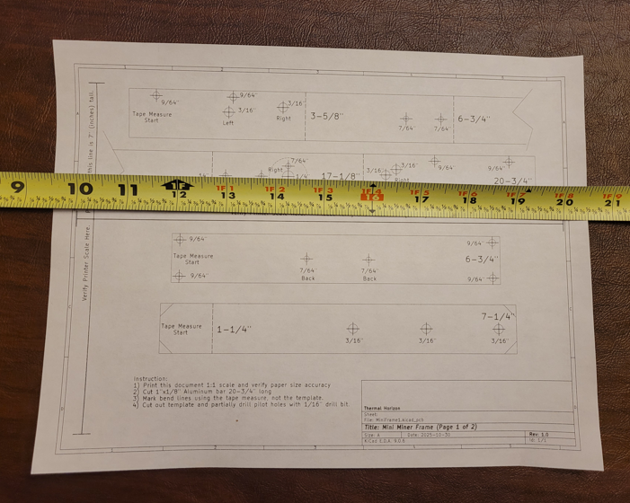 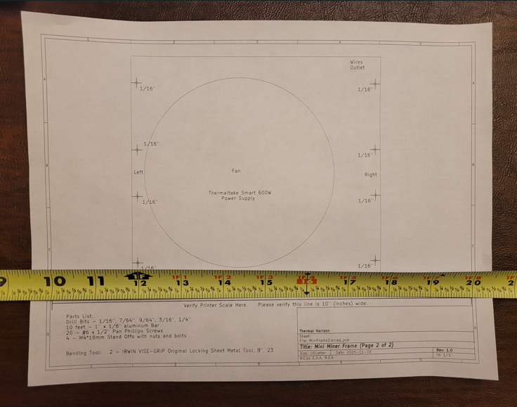

Note: It is very important that these templates are printed actual size.

1. Cut the following pieces of 1 inch aluminum bar. Try to keep the cuts square on these bars.
2. Two bars 20-3/4” long. Label one L and the other R
3. Two bars 6-3/4” long.
4. One bar 7-1/4” long.

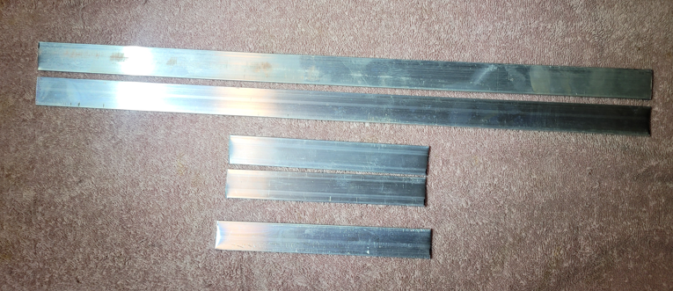

1. If the ends were snipped and not sawed, bend the ends straight.

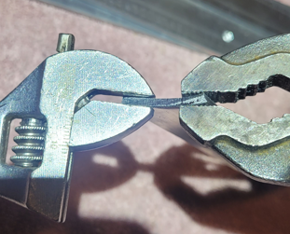

1. Mark the dotted fold lines on the two long pieces and the 7-1/4” piece. Tape the tape measure down to hold it accurate wile marking 3-5/8”, 6-3/4”, 14” and 17-1/8”.

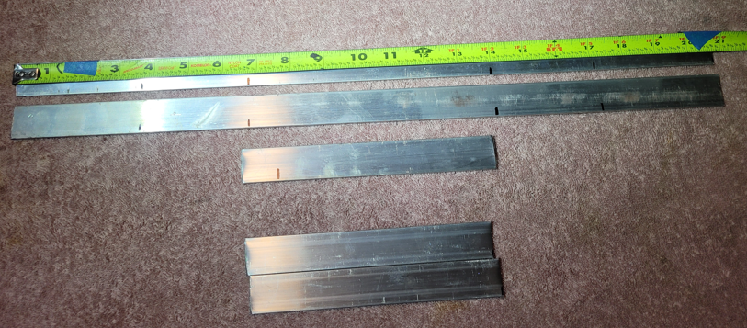

1. Cut the templates out and tape them to the pieces. Be sure to line up the ends accurately on the two long pieces.

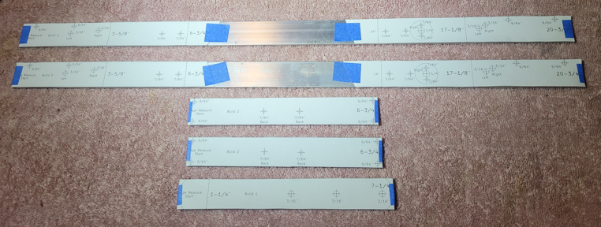

1. Mark the left and right long pieces. Cross out the opposite side holes that are not drilled on those pieces.

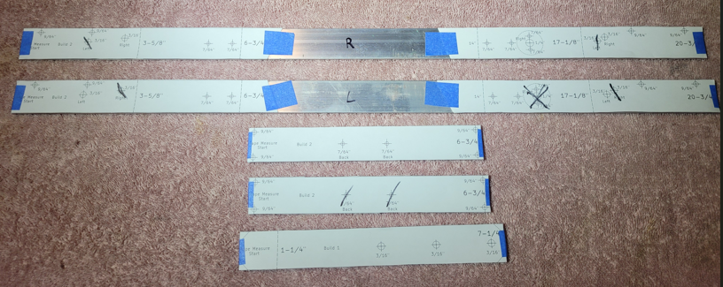

1. Center punch all the holes on all the pieces.

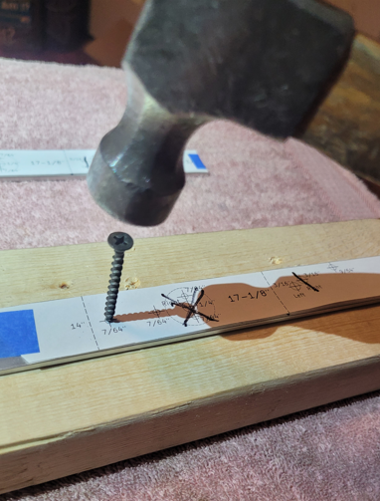 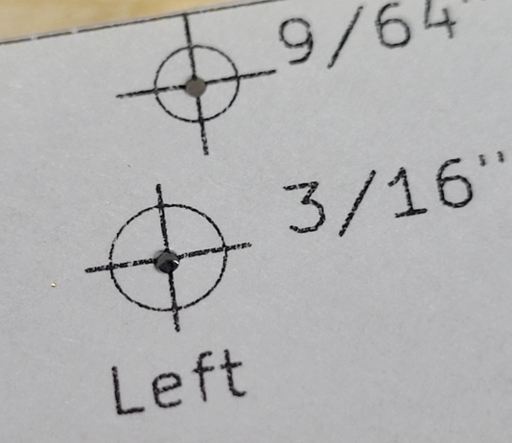

1. Drill 1/16” starter holes in all the pieces. The bit doesn’t have to go all the way thru. This will provide better alignment for the bigger bits.

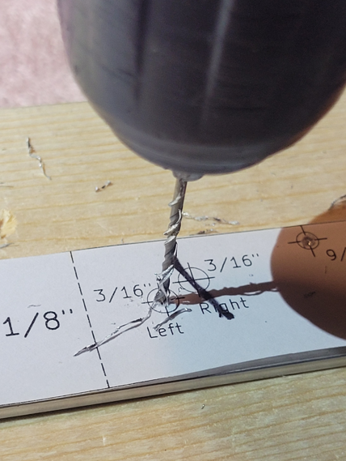 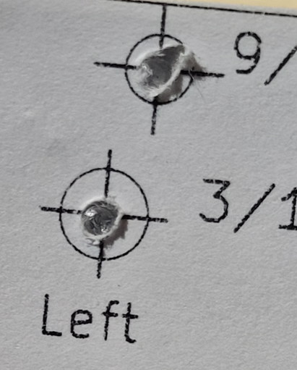

1. Drill all the rest of the holes with the indicated drill bit size.

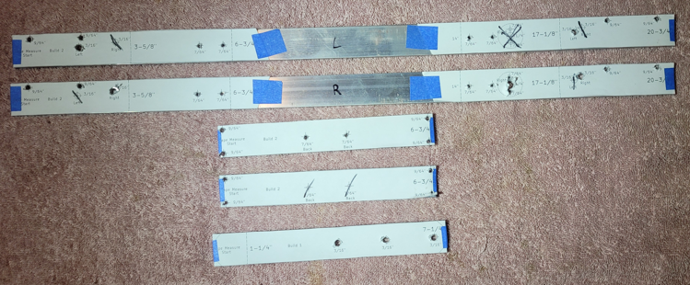

1. Cut the corners off of the hanger hook. The cut lines are marked.

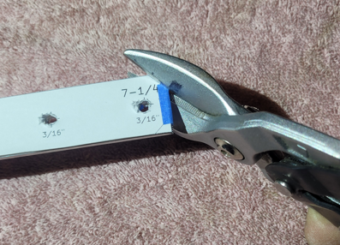

1. Very carefully, debur the holes. Always push the utility knife away from you hand. It doesn’t take much pressure to cut off the aluminum burs.

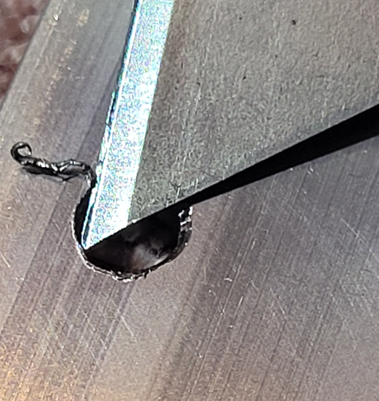

1. Offset the benders to bend the hook. Then close the bend more with pliers. Don’t close more than pictured below.

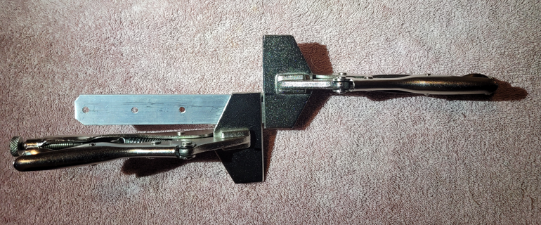 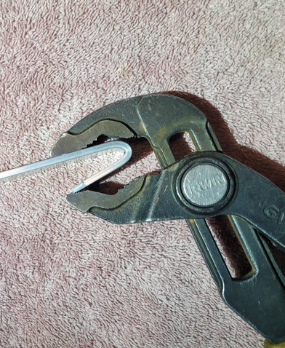

1. Modify the power supply by removing the graphics and HDD wires from the inside. Also remove the fan guard because the motherboard will cover the fan. Also, it will be easier to clean the power supply with an air compressor with the guard off.

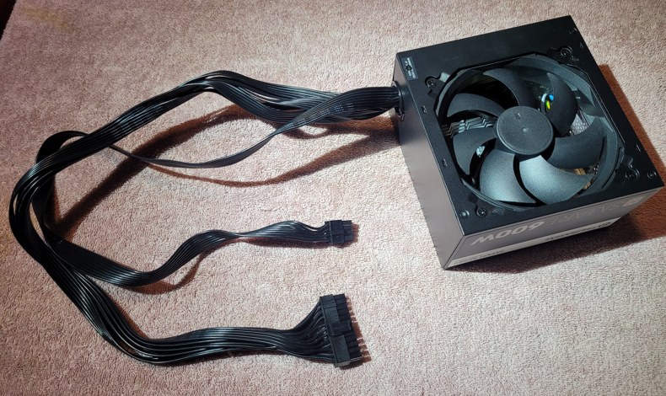

1. Cut out the power supply template and tape it to the top. Notice the front is where the power switch is and the wires outlet is on the top right.

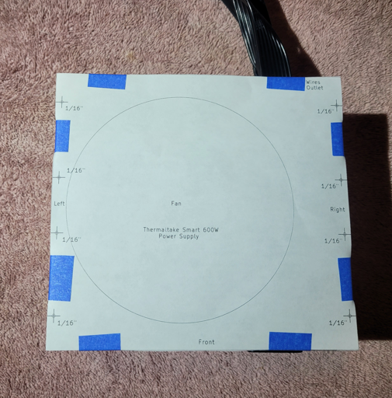

1. Center punch the holes for more accurate drilling. Then drill with a 1/16” drill bit. Try not to go too deep into the power supply to avoid nicking any of the wires.

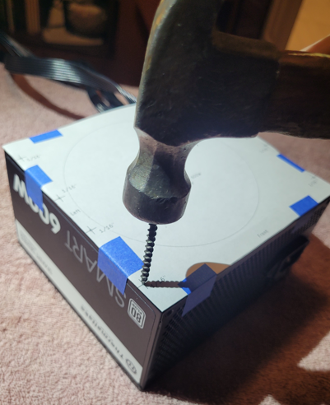 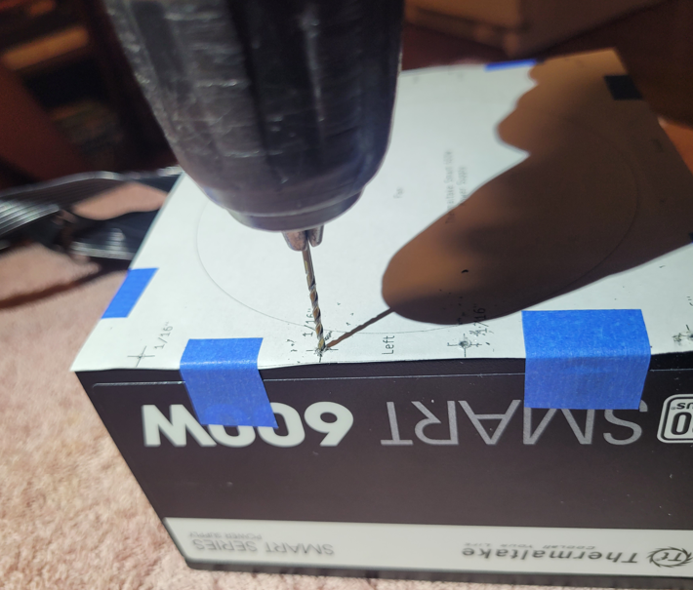

1. Check hole alignment and trim the end of the aluminum if the holes aren’t lined up.

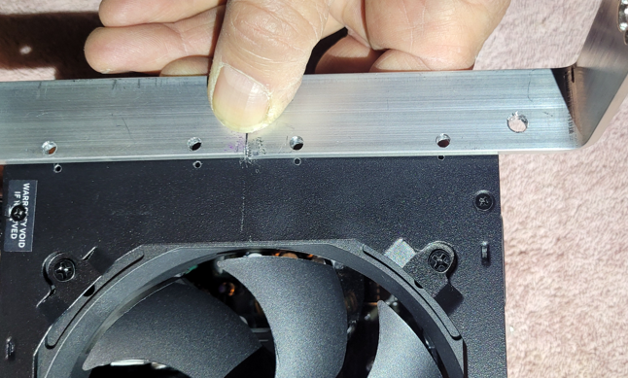 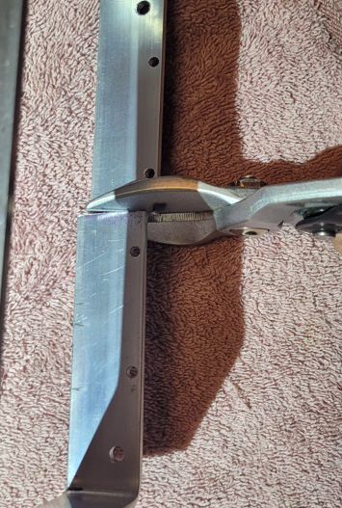

1. Use #6 x ½” screws and start screwing in the right frame to the right side of the power supply.

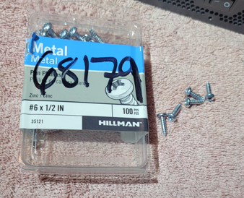 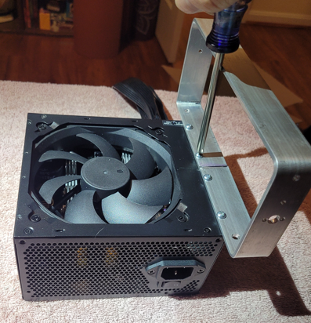

1. Do the same for the left side.

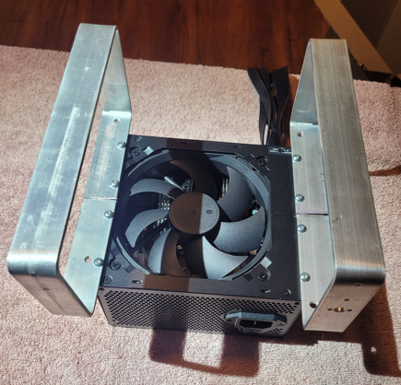

1. Mount the front cross bar with a drill to turn the screws easier. They fit easily thru the bar, but have to self thread the aluminum frame. Start with 2 screws, then finish all 4. Notice the front cross bar does not have the two hook alignment screw holes like the back bar does.

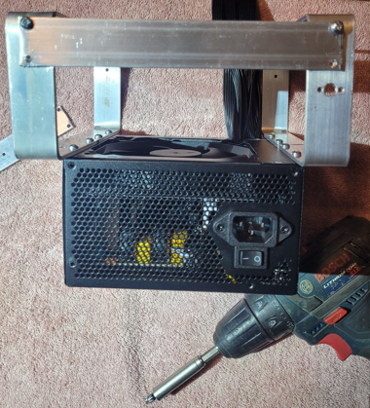

1. Do the same for the back cross bar.

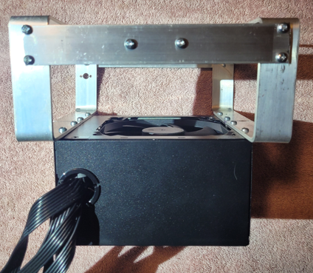

1. Loosely mount the M4 x 18 stand offs in the large frame holes. It is important that they can move around to align perfectly with the mother board because the holes on the motherboard are exactly 4mm as the screws.

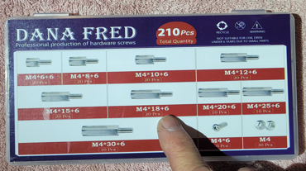 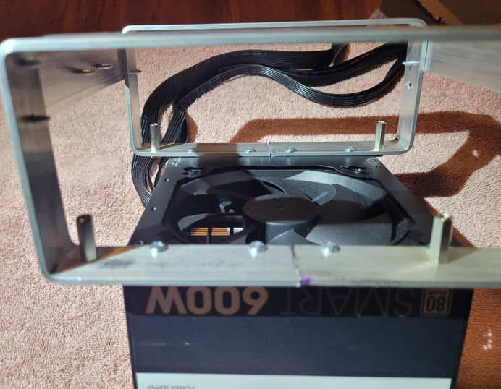

1. The motherboard does not need the back plate. It is a good idea to test it before mounting it in the frame. Also, mount the fan mounts before installing it in the frame.

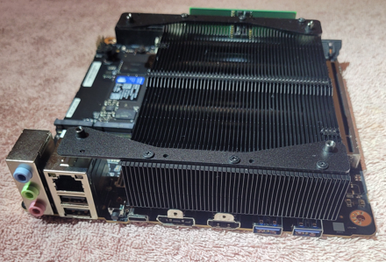

1. Carefully slide the motherboard in the frame. The fan must be removed to clear the side. Gently slide it in and set it on the stand offs.

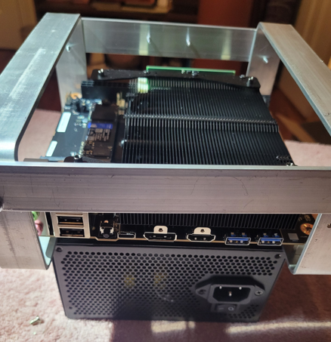

1. Loosely mount the top screws. They will be tightened after all 4 are in place. Notice the screwdriver is at an angle. The screw should be leaned and hand threaded to prevent cross threading.

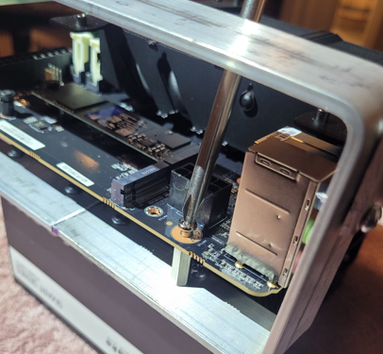

1. Now tighten all 4 motherboard screws on the top. After they are tight, tighten all 4 stand off nuts on the bottom.

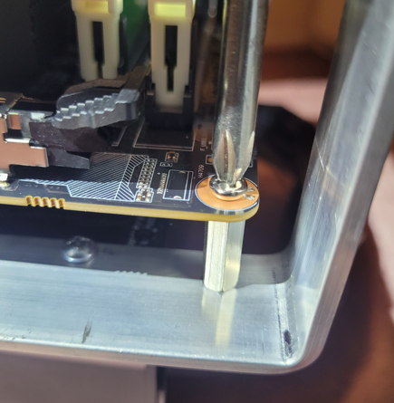 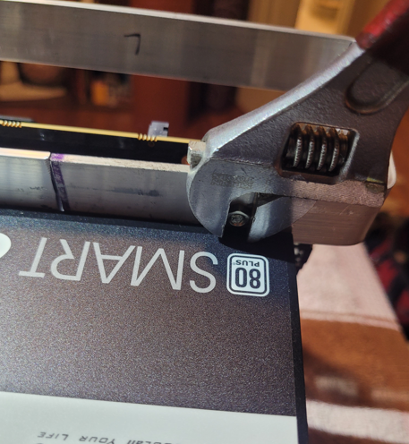

1. Flaten the wires coming out of the power supply and tie them inside the back frame with an 8 inch nylon tie.

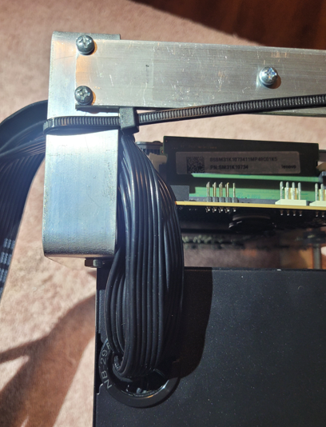

1. The CPU wire is longer than the 24 pin wire. Put the CPU wire next to the top bar so that the 24 PIN wire has less distance to travel. Try to flatten the ribbon cables.

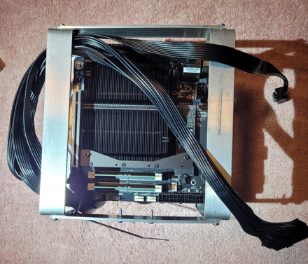

1. Plug in the 24 pin power connector. Do not push it down because the motherboard is very thin. Pinch the connector with your fingers.

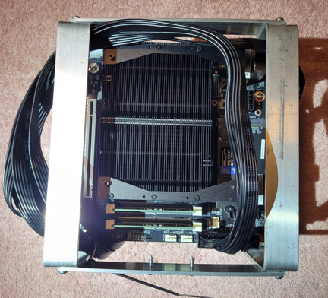 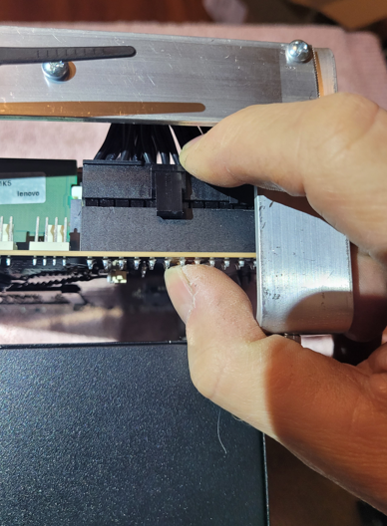

1. Flatten the ribbon wire on the top bar and put two 8” nylon ties on it to hold it to the bar.

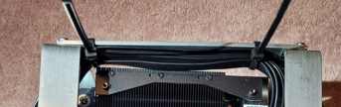

1. Plug the CPU connector by pinching it.

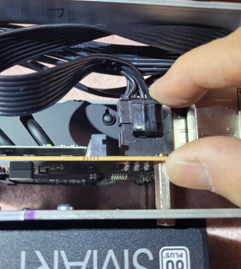

1. Secure the wire on the side. Also, try to ben the wires away from the pointy screws.

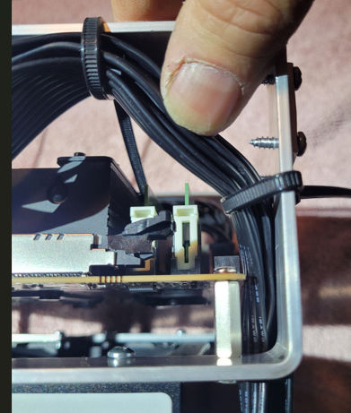

1. Remove the armor from the fan cable so it can be bundled up smaller.

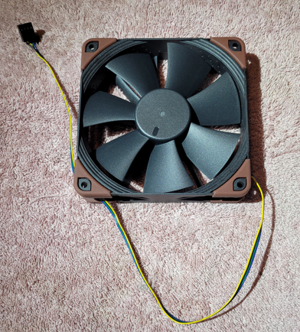

1. Mount the fan with the long screws. Do not tighten too tight. Put the wire close to the 24 pin power connector. There is a 4 pin fan connector labeled CPU there.

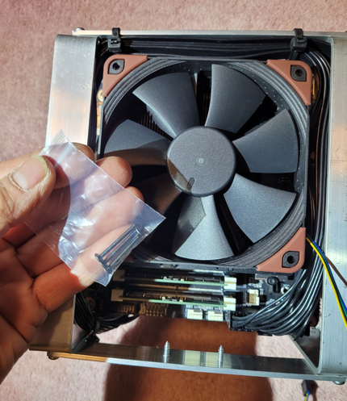

1. Bundle the fan wire and tie it to the fan screw with a 3” nylon tie.

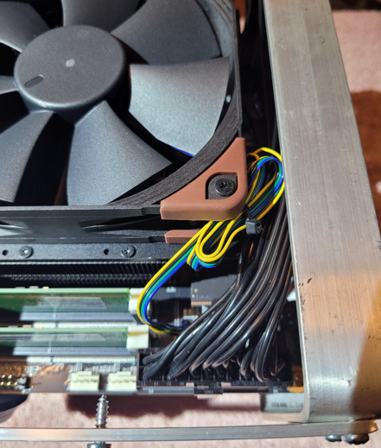

1. Secure any loose wires with 3” nylon ties.

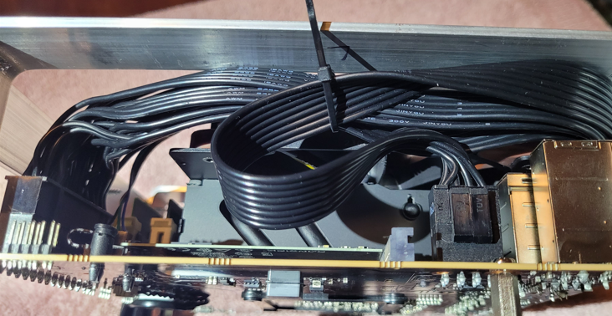

1. Trim half the latch off a 3” nylon tie to mount the switch. Also, use the whole latch from another 3” nylon tie to complete a loop to hold the on/off switch.

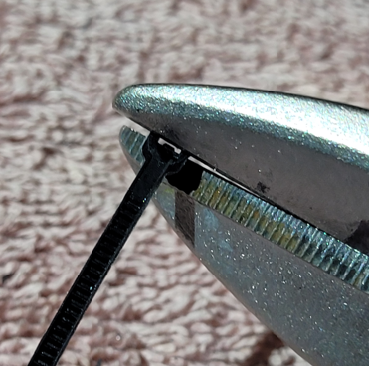 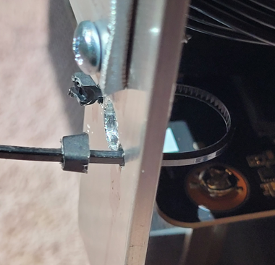 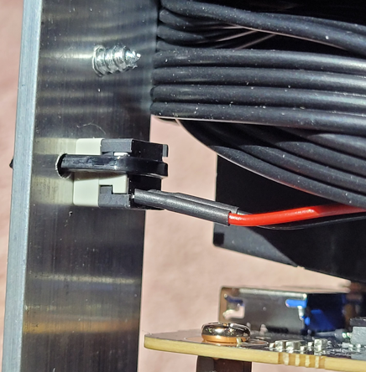

1. Secure the extra power switch wire with a 3” nylon tie and plug it in to the motherboard. It connects to F_Panel pins 6 & 8

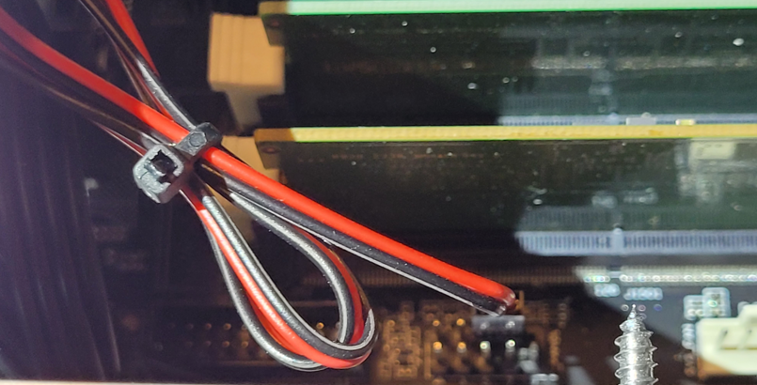

1. Plug in the USB Status LED and the Wifi dongle to the left side USB ports. Those are better quality than the right side ports.

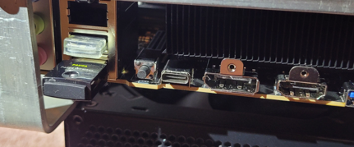

1. Plug in and press the power button to verify the motherboard powers up.

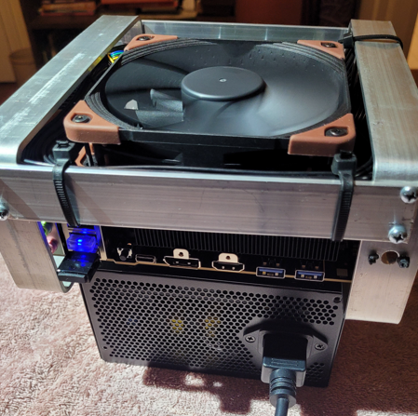

1. This is designed as a headless miner. I have made freeware software that auto updates XMRig, Debian, emails status reports and even reboots with a watchdog. A single Green LED will show everything is operating within specs. Initial setup is done thru the USB-C port with a “LapDock” to handle the keyboard, mouse and video. Once setup is done, the miner is accessed remotely on the local network thru Windows PowerShell running SSH.

Here is the initial setup screen using the LapDock. I have full documentation and videos for the software setup.

